Kunsan National University (KNU)
Exchange Program for International Students

Ⅰ |  | Introduction of KNU

1. Kunsan National University Campus Location

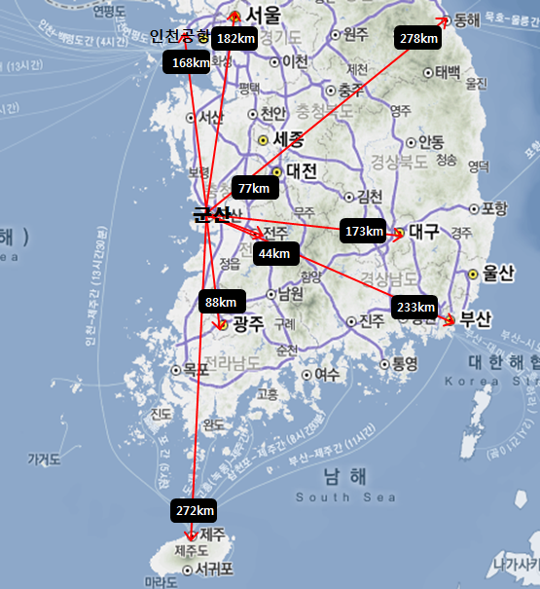 | 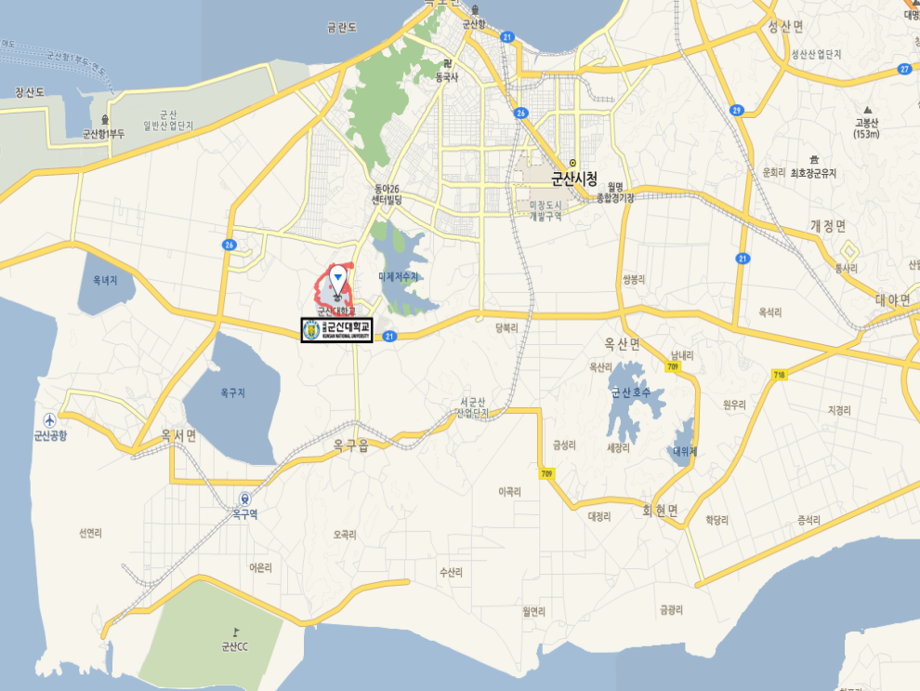
2. Geological Advantage
○ Distance and Transportation from Kunsan to major cities of Kore
City | Distance | Transportation methods and costs |  |  | Remarks
City | Distance | Transportation | Time | Cost | Remarks
Incheon Int’l Airport | 168 km | Intercity bus: First bus 8:20, Last bus 21:40  (Allocation interval110~220min.)  Train: First train 6:10, Last train 19:10  (Transfer in Yongsan station) | 3hrs 30min  4hrs | ₩ 23,700  ₩ 20,700
Seoul | 182 km | Express bus(central): First bus 6:00, Last bus23:00  (Allocation interval 15~30min.)  Train: First train 5:35, Last train 20:35 | 2hrs 30min  3hrs 30min | ₩ 12,200  ₩ 14,600 | General Fare  Mugunghwa-ho Fare
Busan Metropolitan City | 233 km | Intercity bus(East): First bus 7:00, Last bus 19:00 | 4hrs | ₩ 22,000 | General Fare
Daegu Metropolitan City | 173 km | Intercity bus(West): First bus 7:00, Last bus 19:40  (Allocation interval 70~90min.) | 4hrs | ₩ 18,400 | General Fare
Daejun Metropolitan City | 77 km | Intercity bus(Mixed): First bus 8:30, Last bus 19:00  (Allocation interval 60~90min.)  Train: First train 7:05 Last train 20:35 | 1hr 30min  1hr 30min | ₩ 8,800 | General Fare
Kwangju Metropolitan City | 88 km | Intercity bus: First bus 6:30, Last bus 21:00  (Allocation interval 35~60min.) | 1hr 30min | ₩ 11,900 | General Fare
Jeonju, Jeollabuk-do | 44 km | Intercity bus: First bus 6:10, Last bus 23:30  (Allocation intervaloften) | 1hr | ₩ 5,600 | General Fare
Jeju Special Self-Governing Province | 272 km | Refer to Kunsan Airport  :http://www.airport.co.kr/mbs/gunsan/ | 50min

○ Governmental development policy of Honam area: The governmental policy of Honam area, where Kunsan
National University is located, is the development vision of “the Green Industry of the pan-yellow sea area and the creation of culture and tourism area,” which is to develop the eco-friendly Green Industry and tourism industry.
○ Government-promoted Leading Industry of Honam Area: Selected as the New Regeneration Energy Industry and
Eco-friendly Materialand Component Industry
○ Saemangeum Development: The government of the Republic of Korea has built the Saemangeum seawall (33.9km)
in 10 minutes from KNU and has reclaimed 28,300ha of territory; also, it is promoting a national project to build a “Global luxury Saemangeum” of green growth and clean ecological environment, which will emerge as the economic center of Northeast Asia, encompassing economy, industry, and tourism.

3. KNU Size
○ Faculty and Employees: Faculty 412, Employees 211
○ Colleges and Departments, enrollment (as of 2014. 10. 1)
- College of Liberal Arts: 8 departments, 1,203(International students 27)
- College of Arts : 4 departments, 589 (International students 2)
- College of Social Sciences: 9 departments, 1,960 (International students 68)
- College of Natural Sciences: 11 departments, 3,502 (International students 13)
- College of Engineering: 14 departments, 4,313 (International students 38)
- College of Marine Sciences: 10 departments, 1,607 (International students 5)

4. KNU Vision, Concept of Talent, and Specialties
○ KNU Vision 2022 : Best regional education training center moving forward to the world with the Saemangeum
○ KNU Concept of Talent : Talented people with hands-on-experience moving forward to the world with roots in the
region
○ KNU Specialties
▶ Background: KNU specialized fields selected based on the governmental development plan of Honam area (the Green Industry of the pan-yellow sea area and the creation of culture and tourism area), government-promoted leading industry of Honam area (new generation energy industry and eco-friendly material and component industry), and Saemangeum strategic industry (car components, machinery/new generation energy/material industry/ship building, flight, and bio).
▶ KNU Specialties
① Machinery/Automobile/Shipbuilding
② IT Convergence
③ Biology
④ Components and Materials/Environment/Energy
⑤ Marine/Culture/Tourism
⑥ International Business

Ⅱ |  | Current KNU International Exchange

Country | No. | International Exchange Universities | Since | Remarks
USA | 1 | University of Puget Sound, USA | 1984
 | 2 | Montana State University-Bozeman | 1987
 | 3 | Southeast Missouri State University | 1992
 | 4 | College of Engineering, San José State University | 1997
 | 5 | Florida Atlantic University | 1997
 | 6 | Donald Harrison Coll. of Business, Southeast Missouri State University | 1998
 | 7 | Western Washington University | 2000
 | 8 | Florida Atlantic University | 2002
 | 9 | University of South Florida | 2008
 | 10 | Tacoma Community College | 2009
 | 11 | Spartan College of Aeronautics &Technology | 2011
 | 12 | California Int'l Business University | 2011
China | 1 | Ocean University of Qingdao | 1993
 | 2 | Central University of Nationalities | 1996
 | 3 | Liaoning University | 1997
 | 4 | Heilongjiang University | 1997
Country | No. | International Exchange Universities | Since | Remarks
China | 5 | Harbin University of Science &Technology | 1997
 | 6 | Graduate School. Yanbian University | 1998
 | 7 | Yantai Normal University | 1998
 | 8 | Dalian University | 2002
 | 9 | Tianjin Academy of Social Sciences | 2003
 | 10 | Research Institute of Chinese Classics, Fudan U. | 2004
 | 11 | Shanghai Univ. of Finance &Economics | 2004
 | 12 | Soochow University | 2004
 | 13 | Hebei University of Economics &Business | 2008
 | 14 | Capital Normal University | 2010
 | 15 | Dalian Language Translation College | 2012
 | 16 | Yanbian University of Science &Technology | 2012
 | 17 | School of International Studies, Ludong University | 2012
 | 18 | Hunan University of Humanities, Science &Technology | 2012
 | 19 | Marine Science School, Zhehiang Ocean University | 2013
 | 20 | School of Humanities, Zhehiang Ocean University | 2013
 | 21 | Yunnan Land And Resources Vocational College | 2013
 | 22 | Zhehiang Ocean University | 2014
 | 23 | School of Humanities, Zhehiang Ocean University | 2014
Country | No. | International Exchange Universities | Since | Remarks
China | 24 | Dept. ofLogistics, Zhehiang Ocean University | 2014
 | 25 | Qingdao University of Science &Technology | 2014
 | 26 | Jinagsu University | 2014
Germany | 1 | Universität Saarlandes | 1994
 | 2 | Technische Universität Chemnitz | 2001
Hungary | 1 | Miskolci Bölczéz University | 1994
Japan | 1 | Osaka International University | 1996
 | 2 | Kobe University of Mercantile Marine | 1996
 | 3 | Faculty of fisheries, Kagoshima University | 1997
 | 4 | HUMAP Agreement | 2000
 | 5 | Tokyo University of Fisheries | 2001
 | 6 | Soka University | 2001
 | 7 | Kagoshima University | 2002
 | 8 | Kobe University | 2003
 | 9 | Faculty of Engineering, Yamaguchi Univ. | 2005
 | 10 | Faculty of Fisheries, Hokkaido University | 2005
 | 11 | Faculty of Health &Welfare Science, Okayama Prefectural University | 2008
 | 12 | Okayama Institute of Foreign Languages | 2009
 | 13 | Shujitsu University | 2009
Country | No. | International Exchange Universities | Since | Remarks
Japan | 14 | Kagoshima University | 2010
 | 15 | Iwate University | 2011
Russia | 1 | Khabarovsk State Academy of Economics &Law | 1997
Australia | 1 | University of Queensland | 1999
 | 2 | Griffith University | 2002
Philippines | 1 | West Visayas State University | 2003
 | 2 | University of the Philippines | 2011
Thailand | 1 | Burapha University | 2001
Canada | 1 | University of Windsor | 2006
 | 2 | British Columbia Institute of Technology | 2006
Taiwan | 1 | National Taiwan Normal University | 2009
 | 2 | National Chung Hsing University | 2009
Vietnam | 1 | Ly Tu Trong Technical College | 2014
 | 2 | Nguyen Hue High School | 2014
 | 3 | Thang Long Hanoi High School | 2014
Cambodia | 1 | Institute of Technology of Cambodia | 2013
 | 2 | University South-East Asia | 2014
 | 3 | Angkor University | 2014
 | 4 | Build Bright University | 2014
Country | No. | International Exchange Universities | Since | Remarks
Cambodia | 5 | 10Makafa High School | 2014
Mongol | 1 | Ulaanbaatar University | 2013
 | 2 | Transportation Institute | 2014
 | 3 | Khumuun tsogtolbor High School | 2014
 | 4 | 21th Secondary High School | 2014
India | 1 | Pune College of Engineering | 2014
 | 2 | St. Vincent High School | 2014
 | 3 | N.M.V. Prashala and Junior College | 2014
 | 4 | St.Mira’s College for Girls | 2014

Ⅲ |  | Courses in Foreign Languages

College | Department | Class | Language | Open since | Remarks
College of Liberal Arts | Chinese Language & Literature | Korean wave and Korean-Chinese culture | Chinese | 2015. Spring | Confirmed
College of Liberal Arts | Korean Language & Literature | Introduction to Korean language and culture | English | 2015. Spring | Confirmed
College of Liberal Arts | English Language & Literature | Comparison of culture | English | 2015. Spring | Confirmed
College of Social Sciences | School of Business Administration | 1 class (TBD) | English | 2015. Fall | planned
College of Social Sciences | Department of Logistics | 1 class (TBD) | Chinese | 2015. Fall | Planned
College of Social Sciences | Department of Logistics | 2 classes (TBD) | English | 2015. Fall | Planned
College of Engineering | Mechanical & Car Engineering | Class in offshore wind power(TBD) | English | 2016. Spring | Planned
College of Engineering | Ship Building and Marine Engineering | Class in ship building (TBD) | English | 2016. Spring | Planned
College of Marine Sciences | Marine Biomedical Science | Class in fish pathology (TBD) | English | 2016. Spring | Planned

※The above courses are subject to change if circumstances change.

Ⅳ |  | KNU Academic Year

Order | Academic Affairs | Date / Duration | Remarks
1 | Entrance Ceremony | Feb 28, approx.
2 | Beginning of Spring Semester | Mar. 2
3 | Spring semester mid-terms | Apr. 4th week
4 | Spring semester final exams | Jun. 3rd week
5 | End of Spring semester | Jun. 3rd Friday
6 | Summer Vacation | Jun. 3d week ~ Aug. 31 (10 weeks)
7 | Summer classes | Jun. 20~ Jul. 11 (3 weeks)
8 | Commencement | Aug. 3rd week
9 | Beginning of Fall Semester | Sep. 1
10 | Fall semester mid-terms | Oct. 4th week
11 | Fall semester final exams | Dec. 3rd week
12 | End of Fall semester | Dec. 3rd Friday
13 | Winter Vacation | Dec. 4th week ~ Feb. 28 (10 weeks)
14 | Winter classes | Dec. 20 ~ Jan. 10 (3 weeks)
15 | Commencement | Feb. 23, approx.

Ⅴ |  | Student Exchange Programs

1. Student Exchange Program
○ Description: A program which, in accordance with the agreement with an international sister university, invites
exchange students for a semester or full year, where they can receive credits for Korean language and major courses recognized by the sister university.
○ Advantages: As an enrolled student of a sister university, acquire knowledge in one’s field of study from KNU
faculty, and grow an international mindset by experiencing Korean language and culture.
○ Participants: An enrolled student of a university with an agreement of student exchange with KNU.
○ Selection Criteria: Based on the selection criteria of the sister university.
○ Program Participation and After Acceptance

Classification | Procedure | End of Nov. | Dec. 2nd week | Jan. 15 | Feb | End of Feb. | Mar ~ Jun | End of May | Jun. 2nd week | Jul. 10 | Jul. 15 | Aug. 10 | Aug | Aug. 31 | Sep ~ Dec | Jan. 10 | Feb. 10
Spring semester students | E-mail consultation between KNU and sister university
Spring semester students | Student selection (sister university’s own selection criteria )
Spring semester students | Submit Application  (e-mail, int’l mail)
Spring semester students | Acceptance (Letter of invitation e-mail, int’l mail)
Spring semester students | Dormitory Assignment
Spring semester students | Entrance to Korea
Spring semester students | Courses
Spring semester students | Credit acknowledgement
Spring semester students | Transcript forwarding(e-mail, int’l mail)
Fall semester students | E-mail consultation between KNU and sister university
Fall semester students | Student selection (sister university’s own selection criteria )
Fall semester students | Submit Application  (e-mail, int’l mail)
Fall semester students | Acceptance (Letter of invitation e-mail, int’l mail)
Fall semester students | Dormitory Assignment
Fall semester students | Entrance to Korea
Fall semester students | Courses
Fall semester students | Credit acknowledgement
Fall semester students | Transcript forwarding(e-mail, int’l mail)

○ Application Documents
① Application, C.V., consent form for collection ad usage of personal information
- Fill an online application and C.V. in KNU website (URL : http://inter.kunsan.ac.kr/ap_0003.php)
- Download the consent form for collection and usage of personal information from the above URL, sign, convert
into PDF, and upload
② 1 Proof of Enrollment (sister university’s form): Upload in the above URL
③ 1 Transcript (sister university’s form): Upload in the above URL
④ 1 President (Dean)’s letter of recommendation (sister university’s form): Upload in the above URL
⑤ Copy of passport, ID: Upload in the above URL

○ Estimated Costs (based on 1 semester)
Item | Calculation criteria | Costs | Remarks
Tuition | Waived by the student exchange agreement | 0
Boarding  (3 meals/day) | - \949,000~\1,011,000  (depends on room type) | \949,000  ~  \1,011,000 | -May be waived by the student exchange agreement  -Additional expenses for vacation,\15,600/day × 46 days = \717,600
Books | - \30,000~\50,000 per class  - 3 classes×\30,000~\50,000  = \90,000~\150,000 | \90,000  ~  \150,000 | -Book fees may vary depending on the number of enrolled classes
Personal Expenses | - \150,000~300,000 per month  - Min. : 4 months ×\150,000=\600,000  - Max. : 6 months ×\300,000= \1,800,000 | \600,000  ~  \1,800,000 | -Expenses may vary depending on the spending habits of the student
Total |  | \1,639,000  ~  \2,961,000

※ The above costs are subject to change upon the agreement with the sister university, KNU’s circumstances, And other changes.

2. Exchange Student + Transfer Student (Graduate) Attraction Program
○ Description: A program which, after participating in KNU’s exchange student program in accordance with the
agreement with an international sister university, allows students to transfer to KNU (enter graduate
school) after acquiring TOPIK 3rd grade (2nd grade for natural science/engineering)
○ Advantages: Along with the advantages of the student exchange program, acquire bachelor’s (master’s, doctor’s)
degree by transferring to KNU (enter graduate school), after acquiring TOPIK 3rd grade

○ Participants: An enrolled student of a university with an agreement of student exchange with KNU regarding 1+1+2,
2+1+2 or 3+1+2 system
○ Selection Criteria: A student who meets the above criteria and wishes to transfer to KNU (enter graduate school)

○ Description of each system
▶ 1+1+2 system (transfer program from a 2-year college to KNU as a junior student)
① Operation
Undergraduate |  |  |  | Graduate |  | Remarks
` | Sophomore | Junior | Senior | 1st Year | 2nd Year | Remarks
Enroll to the sister university | Enroll to KNU as an exchange student of a sister university | Enroll to KNU after transferring as a junior student |  | Doctoral and master’s degree programs available

② Degree grant: 2-year degree is granted from the sister university; after transferring to KNU and completing
Junior and senior year, the bachelor’s degree is granted from KNU
③Tuition payment
- Freshman: Tuition is paid to the sister university and courses are taken in the sister university
- Sophomore: Tuition is paid to the sister university and courses are taken in KNU
(Tuition in KNU is waived; boarding/books/expenses are individual)
- Junior, Senior: Tuition is paid to KNU, after transferring to KNU as a junior student (boarding/books/expenses are
individual)

▶ 2+1+2 system (transfer program from a 3-year college to KNU as a junior student)
① Operation
Undergraduate |  |  |  |  | Graduate |  | Remarks
Freshman | Sophomore | Junior | Senior | 1st Year | 2nd Year | Freshman | Remarks
Enroll to the sister university |  | Enroll to KNU as an exchange student of a sister university | Enroll to KNU after transferring as a junior student |  | Doctoral and master’s degree programs available

② Degree grant: 3-year degree is granted from the sister university; after transferring to KNU and completing
Junior and senior year, the bachelor’s degree is granted from KNU
③ Tuition payment
- Freshman, Sophomore: Tuition is paid to the sister university and courses are taken in the sister university
- Junior: Tuition is paid to the sister university and courses are taken in KNU
(Tuition in KNU is waived; boarding/books/expenses are individual)
- Junior, Senior: Tuition is paid to KNU, after transferring to KNU as a junior student(boarding/books/expenses are individual)

▶ 3+1+2 system (transfer program from a 4-year college to KNU for graduate school)
① Operation
Undergraduate |  |  |  | Graduate |  | Remarks
Freshman | Sophomore | Junior | Senior | 1st year | 2nd year | Remarks
Enroll to the sister university |  |  | Enroll to KNU as an exchange student of a sister university | Enroll to KNU for doctoral and master’s degree programs |  | Enroll to the graduate program related to courses taken during the exchange program

② Degree grant: the bachelor’s degree is granted from the sister university; after entering and completing KNU’s
graduate school program, the master’s or doctor’s degree is granted from KNU
③ Tuition payment
- Freshman, Sophomore, and Junior: Tuition is paid to the sister university and courses are taken in the sister
university
- Senior: Tuition is paid to the sister university and courses are taken in KNU
(Tuition in KNU is waived; boarding/books/expenses are individual)
- 1st and 2nd year in graduate school: Tuition is paid to KNU, after entering KNU’s graduate school (Tuition in KNU is
waived; boarding/books/expenses are individual)

○ Estimated Costs (based on 1 semester)
Item | Calculation criteria | Costs | Remarks
Exchange Student | -Tuition: Waived by the student exchange agreement  -Boarding (3 meals/day): \949,000~ \1,011,000  -Books: \30,000~\50,000 per class  -Personal expenses: \150,000~\300,000 per month | \1,639,000  ~  \2,961,000 | -Book fees may vary depending on the number of enrolled classes  -Expenses may vary depending on the spending habits of the student  -The calculation is based on 3 courses per semester  -Additional expenses for vacation,  \15,600/day × 46 days = \717,600
Transfer Student | -Tuition (costs may vary each year)  ·Liberal Arts/Social Sciences: \1,665,000  ·Natural Sciences: \1,985,000  ·Engineering/Arts: \2,127,000  -Boarding (3 meals/day) : \949,000~ \1,011,000  -Books: \30,000~\50,000 per class  -Personal expenses: \150,000~\300,000 per month | \3,694,000  ~  \5,288,000 | - Boarding expenses are waived for transfer students for 1 year  -The calculation is based on 6~7 courses per semester  -Book fees may vary depending on the number of enrolled classes  -Expenses may vary depending on the spending habits of the student  -Additional expenses for vacation,  \15,600/day × 46 days = \717,600
Graduate Student | -Tuition (costs may vary each year)  ·Liberal Arts/Social Sciences: \1,946,500  ·Natural Sciences: \2,284,500  ·Engineering/Arts: \2,435,000  -Boarding (3 meals/day): \949,000~ \1,011,000  -Books: \30,000~\50,000 per class  -Personal expenses: \150,000~\300,000 per month | \3,945,500  ~  \5,496,000 | -Book fees may vary depending on the number of enrolled classes  -Tuition and living costs may be supported when participating the research project of the academic adviser

※ The above costs are subject to change upon the agreement with the sister university, KNU’s circumstances, and
other changes.
○ KNU Scholarships (based on 1 semester)
Scholarship | Criteria | Amount | Payment Method | Remarks
Merit based scholarship A | GPA 4.00~4.50 | \1,000,000 | Provided based on GPA after completing each semester
Merit based scholarship B | GPA 3.50~3.99 | \700,000 | Provided based on GPA after completing each semester
Merit based scholarship C | GPA 3.00~3.49 | \500,000 | Provided based on GPA after completing each semester
Freshman Scholarship | All freshman/transfer students | \700,000 | Provided to all freshman and transfer students
Life-support Scholarship | All freshman/transfer students entering residence halls | \1,000,000 | Provided to all freshman and transfer students entering residence halls

3. Exchange Students + Korean Language Class+ Transfer Student (Graduate) Attraction Program
○ Description: A program which, after participating in KNU’s exchange student program in accordance with the
agreement with an international sister university, allows students to transfer to KNU (enter graduate school) after acquiring TOPIK 3rd grade (2nd grade for natural science/engineering) by taking Korean language classes for a semester or a full year, and
○ Advantages: Along with the advantages of the student exchange program, obtain TOPIK 3rd grade (2nd grade for natural science/engineering) by taking Korean language classes, transfer to KNU (enter graduate school), and obtain bachelor’s (master’s, doctor’s) degree
○ Participants: An enrolled student of a university with an agreement of student exchange with KNU regarding 1+1+2,
2+1+2 or 3+1+2 system
○ Selection Criteria: An enrolled student of the university in agreement with KNU for the operation of the above
systems who wishes to transfer to KNU (enter graduate school)

○ Operation
Exchange student program | Korean language classes | Entering KNU | Remarks
- 1+1+2 system  exchange student | 6-month or 1 year program | Transfer to KNU as a junior student after obtaining TOPIK 3rd grade
- 2+1+2 system  exchange student | 6-month or 1 year program
- 3+1+2 system  exchange student | 6-month or 1 year program | Enter KNU graduate school

○ Estimated Costs (based on 1 semester)
▶Exchange/transfer/graduate students: Refer to the estimated costs of “2. Exchange student + transfer student
(graduate) attraction program.”
▶Contact hours per program: 6-month program: 20 weeks, 400hrs/ 1 year program: 40weeks, 800hrs
▶Expected costs for Korean language classes
Classification | Contact hours | Tuition | Books | Boarding  (3식 포함) | Personal Expenses | Insurance | Expected Costs | Remarks
6-month program | 20 weeks, 400hrs | \2,400,000 | \200,000 | -Semester :\949,000  ~1,011,000  -Vacation : \15,600×40days = \624,000 | -\ 150,000  ~ \300,000/month | -\200,000~ \300,000/year | \5,366,600  ~  \6,428,600
1 year program | 40 weeks, 800hrs | \4,800,000 | 400,000원 | -Semester : 949,000  ~1,011,000원  -Vacation : \15,600×40days = \624,000 | -\ 150,000  ~ \300,000/month | -\200,000~ \300,000/year | \7,966,600  ~  \9,028,600

※The above costs are subject to change upon KNU’s circumstances and other changes.

Ⅵ |  | Korean Language Classes

1. Program Basics (based on 1 year)
○ # of semesters: Total 4(Spring, Summer, Fall, Winter)
○ Contact hours per semester: 4hrs/day, 5days/week, 10 weeks, 200hrs
○ Classes and Schedule

▶ Basic (Subject to change upon KNU’s circumstances)
Period | Hours | Mon | Tue | Wed | Thu | Fri
1 | 09:10~10:00 | Speaking/Listening | Speaking/Listening | Grammar | Grammar | Grammar
2 | 10:10~11:00 | Speaking/Listening | Speaking/Listening | Grammar | Grammar | Grammar
3 | 11:10~12:00 | Reading/Writing | Reading/Writing | Reading/Writing | Speaking/Listening | Speaking/Listening
4 | 12:10~13:00 | Reading/Writing | Reading/Writing | Reading/Writing | Speaking/Listening | Speaking/Listening

▶Intermediate · Advanced (Subject to change upon KNU’s circumstances)
Period | Hours | Mon | Tue | Wed | Thu | Fri
1 | 09:10~10:00 | Speaking/Listening | Grammar | Grammar | Speaking/Listening | TOPIK
2 | 10:10~11:00 | Speaking/Listening | Grammar | Grammar | Speaking/Listening | TOPIK
3 | 11:10~12:00 | Reading/Writing | Reading/Writing | Speaking/Listening | TOPIK | TOPIK
4 | 12:10~13:00 | Reading/Writing | Reading/Writing | Speaking/Listening | TOPIK | TOPIK

※ TOPIK : Lectures in preparation for TOPIK

2. Operation
○ Level classification: 4 levels [basic, intermediate(low), intermediate(high), advanced]
○ Level tests for first-time students ->class placement
○ Mid-terms and Evaluations throughout the program
○ Class teacher system for each level

3. Participation
○ Qualification for application
- A foreigner whose mother language is not Korean
- A foreigner with a high school diploma or the equivalent
○ Application Items
Classification | Application Items | Remarks
-Overseas students | - 1 application (attachment 1)  - 3 color photos (white background, taken within 6 months, 3.5cm×4.5cm size)  - 1 diploma, 1 transcript  - 1 academic certificate  - 1 Copy of passport,  - 1 copy of ID of the applicant and parent  - Family relations certificate (issued within 6 months)  (Ex: China-census document, Vietnam-family register or birth certificate, Philippines-Family Census)  - 1 proof of employment of parents  - 1 Bank statement (balance $5,000 or more, issued within 6 months)  - Confirmation of translation [documents in other than English shall be translated into English or Korean by someone other than the applicant, and be signed by the applicant](Attachment 2)  - Other requested miscellaneous documents for admission to KNU

Classification | Application Items | Remarks
- Korean Language Program students residing in Korea | - 1 application Form (Attachment 1)  - 3 color photos (white background, taken within 6 months, 3.5cm×4.5cm size)  - 1 certificate of enrollment of current school  - 1 official transcript of current school  - 1 certificate of graduation  - 1 official final transcript  - 1 proof of family relationships (issued within 6 months)  (ex: China-census document, Vietnam-family registeror birth certificate, Philippines-Family Census)  - 1 last school certification document  - Bank statement (balance \3,000,000 or more, including the original bankbook)  - Certificate of residency (admission letter for housing or a lease contract)  - Confirmation of translation [documents in other than English shall be translated into English or Korean by someone other than the applicant, and be signed by the applicant](Attachment 2)  - Other requested miscellaneous documents for admission to KNU

○ Korean language education program and procedures
No | Procedure | Details | Spring | Summer | Fall | Winter
1 | Submit Application | The applicant submits the application form and required documents to KNU via international mail, etc. | Dec. 3rd ~ 4th week of previous year | Mar. 3rd~4th week | Jun. 3rd~4th week | Sep. 3rd~4th week
2 | Document Revision | Authenticity and omission of documents are reviewed | Jan. 1st week | Apr. 1st week | Jul. 1st week | Oct. 1st week
3 | Apply for visa for Korea | Apply for visa in immigration | Jan. 2nd week | Apr. 2nd week | Jul. 2nd week | Oct. 2nd week
4 | Notification of visa number | Visa issuance number is transmitted to the applicant via e-mail or international mail | ~ Feb. 2nd week | May 2nd week | Aug. 2nd week | Nov. 2nd week
5 | Visa Issuance | The applicant is issued of a visa by submitting the visa issuance number and required documents to the Korean Embassy | ~ Feb. 3rd week | May 3rd week | Aug. 3rd week | Nov. 3rd week
6 | Enter Korea | The applicant visits Korea | ~ Feb. 4th week | May 4th week | Aug. 4th week | Nov. 4th week
7 | Education period | After the level test, the applicant is placed in the appropriate class and takes classes for 10 weeks and 200 hours per semester | Mar. 1st week ~ May 2nd week | Jun. 1st week ~ Aug. 2nd week | Sep. 1st week ~ Nov. 2nd week | Dec. 1st week ~ Feb. 2nd week of next year

※The above costs are subject to change upon KNU’s circumstances and other changes.

※Visa Issuance for Korean Language Program students or transfer students※
1. Korean Language Program students are issued of a D4 visa (general trainee) for 2 semesters.
2. A Korean Language Program students entering Spring semester shall submit the following documents and request a visa extension.
①1 certificate of payment for next semester (issued by KNU without fee)
②1 certificate of enrollment (issued by KNU without fee)
③1 official transcript (issued by KNU without fee)
④Passport, certificate of alien registration
⑤1 certificate of residency (certificate of current residency in Korea; if residing in KNU’s dormitory, then ‘admission letter for housing’ (issued in the administration office of the residence hall)
⑥Bank statement (bank account in the name of the applicant with balance of \1,800,000 or more)
⇒The visa can be extended for a semester by submitting the above documents;
from then, the visa is extended every semester
3. If the Korean Language Program student obtains TOPIK 3rd grade (2nd grade for natural science/engineering) and enters KNU as a freshman, the D4 visa is changed to D2 visa (student).

